**Collatz Conjecture Verification: A Many-Core Approach**

Midwestern State University   
Scott Gordon, Steven Kundert

Dr. Eduardo Colmenares (Faculty Mentor)

The Collatz conjecture or Ulam’s Conjecture is a famous unsolved problem from mathematics that has never been proven. The series of numbers created by the conjecture is known as the hailstone sequence. Although no proof exists most mathematicians who have examined the problem believe it is true because of the large amount of experimental evidence to support it.

In this research, we present two different implementations, which perform Collatz verification. The first, a traditional sequential approach executed in a standard many-core CPU and the second, a parallel implementation in a Graphical Processing Unit (GPU). GPU’s hardware is considered a many-core architecture, and are capable of intense floating point operations which if properly harnessed can lead to an accurate solution in a fraction of the time of its traditional CPU counterpart. This research will present the scope the problem, algorithms, design choices and a comparison between both approaches.

The code submitted, can be compiled with the following command on a compatible system: /opt/cuda-8.0/bin/nvcc TwoLoopsSequential.cu -o TwoLoops

The code can then be executed by running the command:

./TwoLoops

An output file by the name of VerifyConjecture.txt is created in the local directory.

The Following image shows a sample of our output file and is intended only for verification purposes.

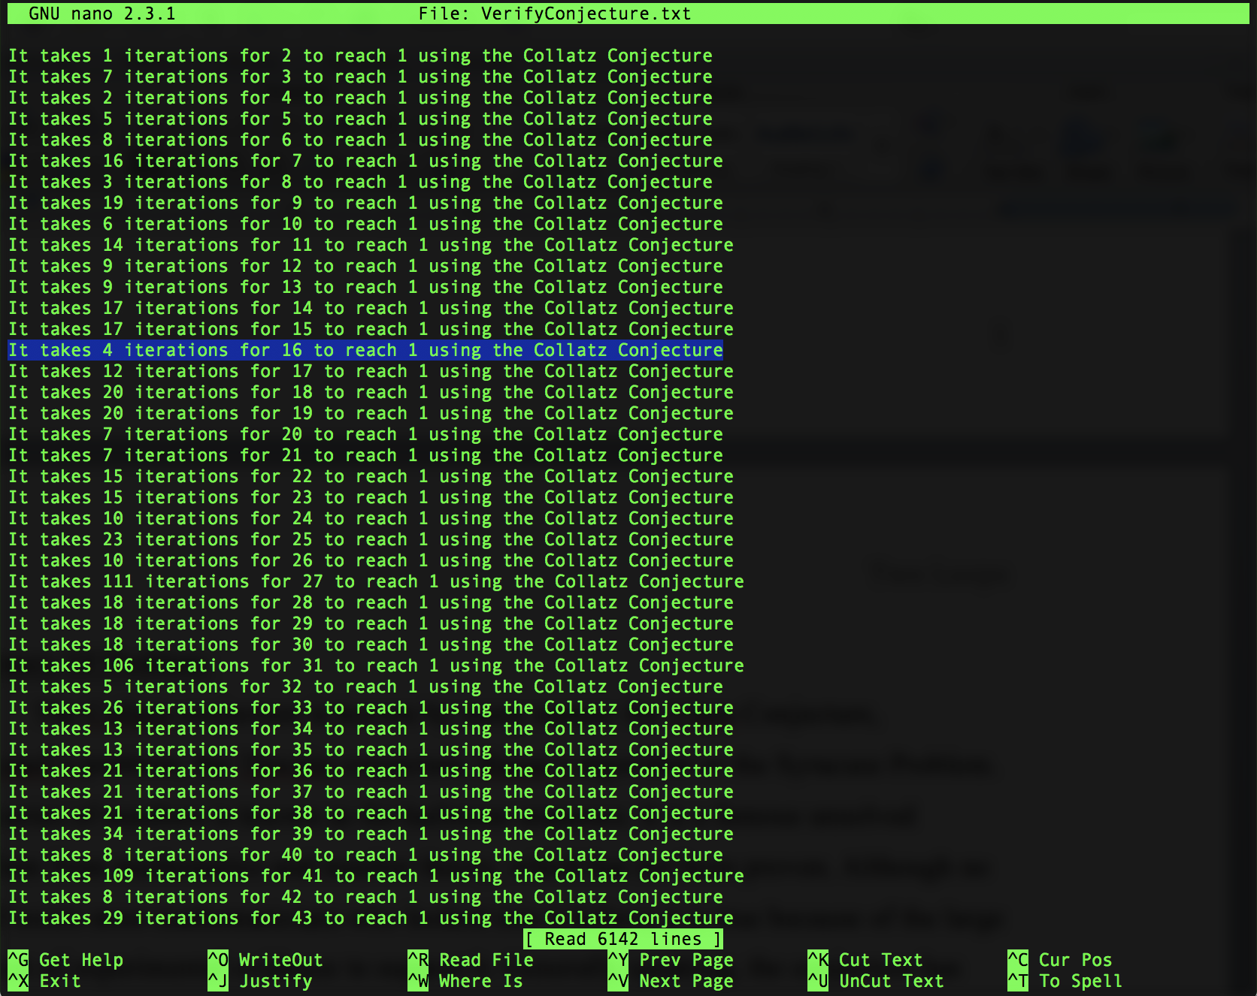

As you can see it is claimed the number 16 takes 4 iterations to reach one. Lets test that by hand:

16 => 8 => 4 => 2 => 1 (4 iterations)